Conor Peckham
Exercise 3
Part 1
using System;
using System.Collections.Generic;
using System.Linq;
using System.Text;
using System.Threading.Tasks;

namespace ConsoleApp4
{
class Program
{
static void Main(string[] args)
{
string FirstName, LastName;
int IDnumber;
double PayRate, Hours, GrossPay, TaxDeduct, NetPay;
FirstName = Console.ReadLine();
LastName = Console.ReadLine();
IDnumber = Convert.ToInt32(Console.ReadLine());
PayRate = Convert.ToInt32(Console.ReadLine());
Hours = Convert.ToInt32(Console.ReadLine());

GrossPay = PayRate*Hours;
TaxDeduct = GrossPay*0.2;
NetPay = GrossPay-TaxDeduct;
Console.WriteLine("Name: \t\t" + LastName + ", " + FirstName);
Console.WriteLine("Hours: \t\t" + Hours);
Console.WriteLine("Pay Rate: \t" + PayRate);
Console.WriteLine("Gross Pay: \t" + GrossPay);
Console.WriteLine("Tax Deduction: \t" + TaxDeduct);
Console.WriteLine("Net Pay: \t" + NetPay);

Console.ReadKey();
}
}
}

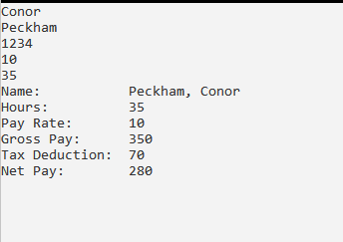
Part 2
using System;
using System.Collections.Generic;
using System.Linq;
using System.Text;
using System.Threading.Tasks;

namespace ConsoleApp4
{
class Program
{
static void Main(string[] args)
{
string FirstName, LastName;
int IDnumber;
double PayRate, Hours, GrossPay;
FirstName = Console.ReadLine();
LastName = Console.ReadLine();
IDnumber = Convert.ToInt32(Console.ReadLine());
PayRate = Convert.ToInt32(Console.ReadLine());
Hours = Convert.ToInt32(Console.ReadLine());

GrossPay = PayRate*Hours;

Console.WriteLine("Name: \t\t" + LastName + ", " + FirstName);
Console.WriteLine("Hours: \t\t" + Hours);
Console.WriteLine("Pay Rate: \t" + PayRate);
Console.WriteLine("Gross Pay: \t" + GrossPay);
Console.WriteLine("Tax Deduction: \t" + computeTax(GrossPay));
Console.WriteLine("Net Pay: \t" + computeNetPay(GrossPay));

Console.ReadKey();

double computeTax(double gross)
{
double Tax;
Tax = gross * 0.2;
return Tax;
}
double computeNetPay(double gross)
{
double Net;
Net = gross - computeTax(gross);
return Net;
}
}
}
}

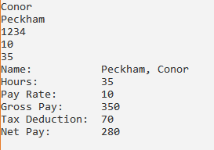

Part 3
using System;
using System.Collections.Generic;
using System.Linq;
using System.Text;
using System.Threading.Tasks;

namespace ConsoleApp4
{
class Program
{
static void Main(string[] args)
{
string FirstName, LastName;
int IDnumber;
double PayRate, Hours, GrossPay, NetPay, TaxDeduct;
FirstName = Console.ReadLine();
LastName = Console.ReadLine();
IDnumber = Convert.ToInt32(Console.ReadLine());
PayRate = Convert.ToInt32(Console.ReadLine());
Hours = Convert.ToInt32(Console.ReadLine());

GrossPay = PayRate*Hours;
TaxNetPay(out TaxDeduct, out NetPay, GrossPay);

Console.WriteLine("Name: \t\t" + LastName + ", " + FirstName);
Console.WriteLine("Hours: \t\t" + Hours);
Console.WriteLine("Pay Rate: \t" + PayRate);
Console.WriteLine("Gross Pay: \t" + GrossPay);
Console.WriteLine("Tax Deduction: \t" + TaxDeduct);
Console.WriteLine("Net Pay: \t" + NetPay);

Console.ReadKey();
}

public static void TaxNetPay(out double tax, out double net, double gross)
{
tax = gross * .2;
net = gross - tax;
}
}
}

